CSA1110 – OBJECT ORIENTED ANALYSIS & DESIGN

EXP 1 PASSPORT MANAGEMENT SYSTEM

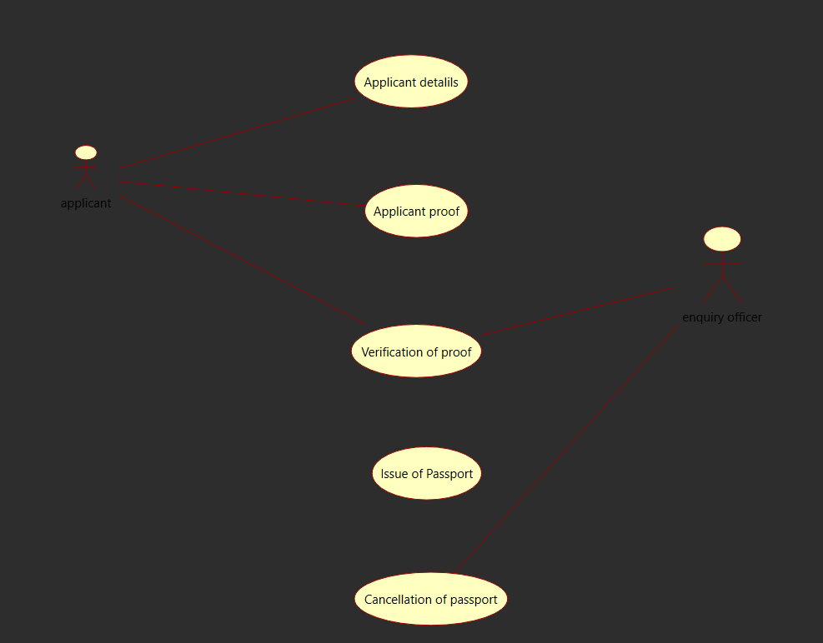
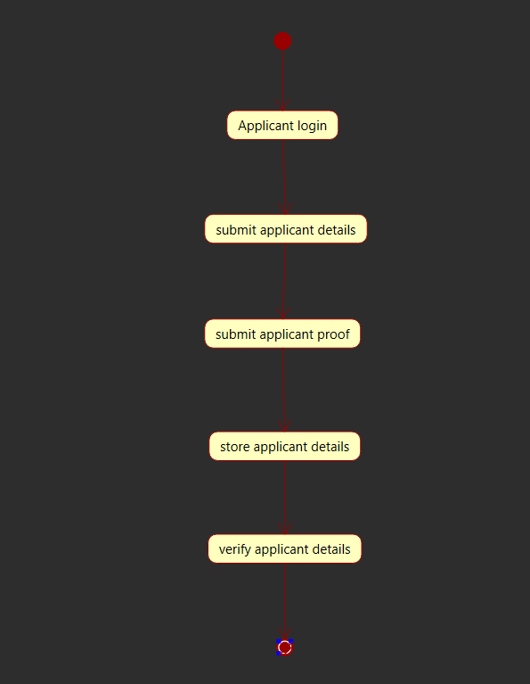
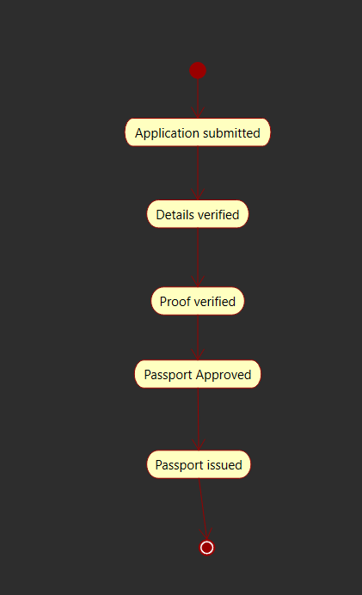
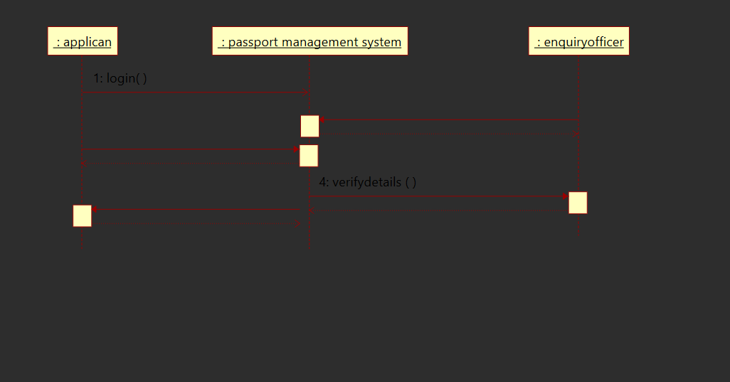
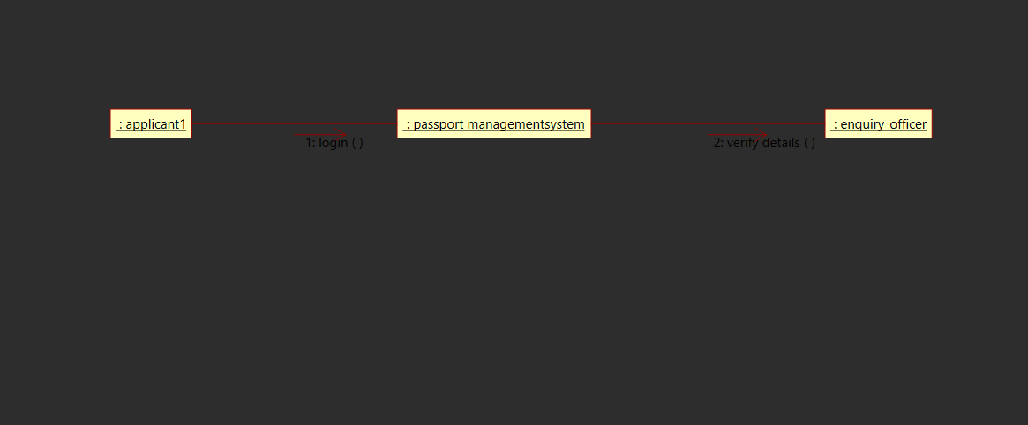
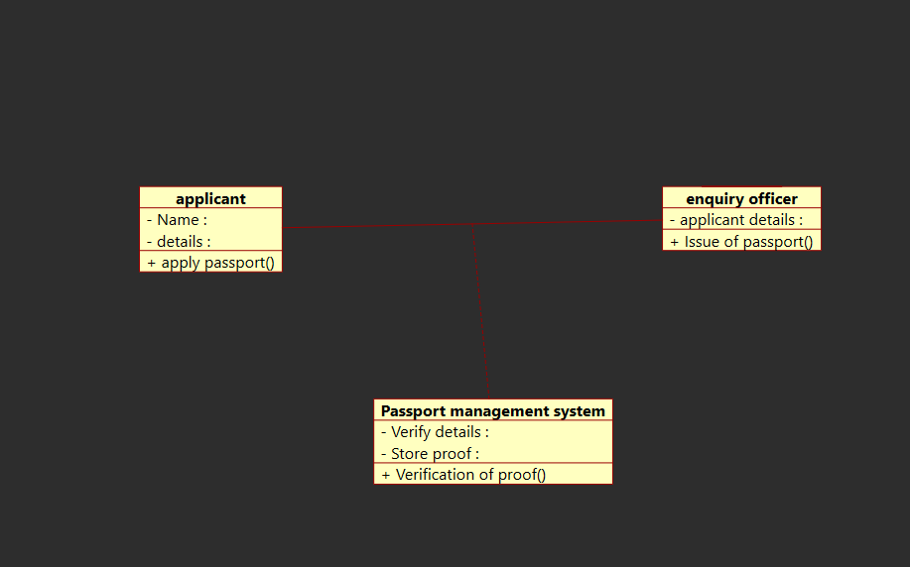
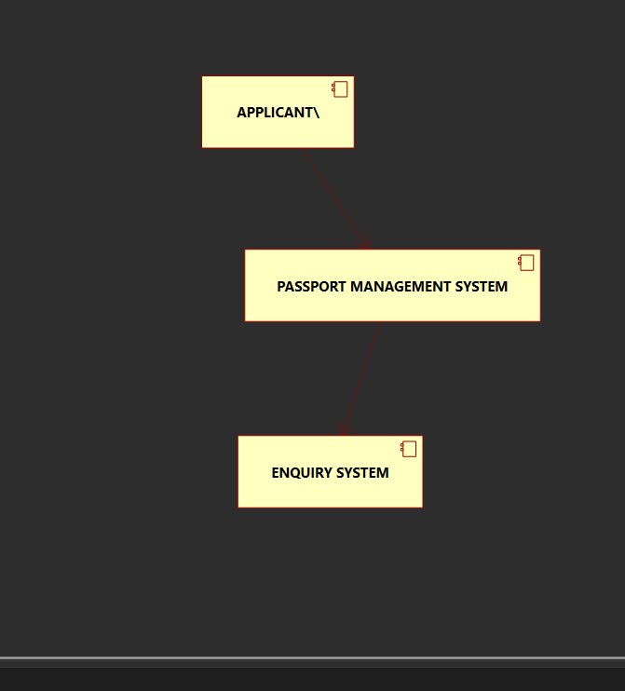
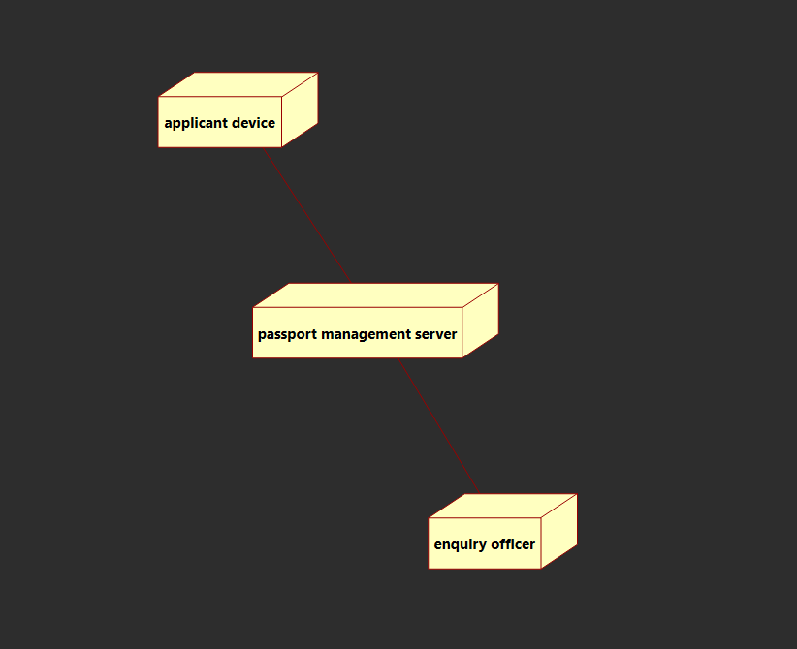

CODE

class ENQUIRY_OFFICER:

"""
:version:
:author:
"""

""" ATTRIBUTES

APPLICANT_DETAILS (private)

"""

def ISSUE_OF_PASSPORT(self):
"""

@return :
@author
"""
pass
from ENQUIRY_OFFICER import *

class PASSPORT_MANAGEMENT_SYSTEM:

"""
:version:
:author:
"""

""" ATTRIBUTES

PASSPORT_DETAILS (private)

APPLICANT_DETAILS (private)

"""

def VERIFY_DETAILS(self):
"""

@return :
@author
"""
pass

def VERIFY_PROOF(self):
"""

@return :
@author
"""
pass

from PASSPORT_MANAGEMENT_SYSTEM import *

class APPLICANT:

"""
:version:
:author:
"""

""" ATTRIBUTES

NAME (private)

DETAILS (private)

"""

def APPLY_PASSPORT(self):
"""

@return :
@author
"""
Pass

